Modern E-Learning Platform using Strapi and Nextjs

{Solely making it in PHP as discussed with the supervisor}
Software Requirements Specification

Version 1.0



Group Id: F24PROJECTD409E
Supervisor Name : Amjad Iqbal Khan

Revision History

Date (dd/mm/yyyy) | Version | Description | Author
26/11/2024 | 1.0 | An SRS document is a detailed description of a web-based system, explaining its purpose and features. For this Modern E-Learning Platform, the document will cover the scope of the project, outlining the goals and what the platform will include. It will also describe the functional and non-functional requirements. The use case diagram will show how users (students and instructors) interact with the platform, while usage scenarios will give examples of how the platform will be used in real life. The document will explain the adopted methodology (how the platform will be developed, using PHP), and the work plan will show the timeline and tasks for completing the project, typically created using MS Project. This helps everyone involved understand the project and its development process. | BC190203051

Table of Contents

- Scope (of the project)
- Functional Requirements Non Functional requirements
- Use Case Diagram
- Usage Scenarios
- Adopted Methodology
- Work Plan (Use MS Project to create Schedule/Work Plan)

SRS Document

Scope of Project:
The Modern E-Learning Platform is a PHP-based system built to meet the growing demand for online education. It will help create and manage courses, deliver high-quality content, and ensure an interactive, personalized learning experience. Key features include course catalogs, multimedia support, progress tracking, and certifications.
The platform will be developed using PHP for its flexibility, ease of use, and ability to integrate with various systems. PHP’s strong backend will handle content management, user authentication, and secure transactions. This platform will provide a scalable, accessible solution that ensures smooth performance and a great user experience.

Functional and non-Functional Requirements:
Functional Requirements
- User Authentication and Authorization:
  - User registration and login for students, instructors, and admins.
  - Role-based access control (students, instructors, admins) to restrict access to features.
- Course Management:
  - Course creation, editing, and deletion by instructors and admins.
  - Multimedia content support (videos).
  - Courses Support Management.
- Student’s Enrollment:
  - Students can enroll in free or paid courses.
  - Payment gateway integration for course purchases (Optional)
I’ve used manual enrollment process and approval system.
  - Track student progress across courses.
- Lesson and Content Delivery:
  - Interactive lessons with video resources.
- Course Feedback and Reviews:
  - Students can rate and leave reviews for completed courses.
  - Instructors/Administrator can view feedback to improve courses.
- Instructor Dashboard:
  - Instructors can create and manage courses via a user-friendly dashboard.
  - View and track student progress and course completion rates.
  - Upload course materials such as videos.
- Admin Dashboard:
  - Admins can manage users (students, instructors).
  - Admins can Keep or delete courses.
- Progress Tracking and Certification:
  - Performance tracking of students.
  - Manually Certification generation request of course upon completion.
- Mobile-Friendly Design:
  - Fully responsive design to ensure usability across mobile and tablet devices.
  - Students can download lessons for offline viewing.
- Search Functionality:
  - Search and filter options for finding courses, lessons, or instructors based on keywords or categories.

Non-Functional Requirements
- Performance:
  - Fast page load times, with optimized media and resources to ensure smooth operation.
  - Efficient database queries and caching mechanisms to improve performance during high traffic.
- Scalability:
  - The system should be scalable to accommodate more courses, users, and content without performance degradation.
- Security:
  - Secure user authentication using encrypted passwords and tokens.
  - Role-based access control to prevent unauthorized access to data and features.
  - Secure payment gateway integration as manual approval & Proof submission of payments for online fraud prevention in transactions.
- Reliability:
  - The platform should have high availability with minimal downtime.
- Usability:
  - Easy navigation for browsing courses, lessons, and progress tracking.
  - Simple course creation and management process for instructors.
- Compatibility:
  - Cross-browser compatibility to ensure the platform works on popular browsers like Chrome, Firefox, Safari, and Edge.
  - Compatibility with various devices, ensuring a consistent user experience across desktop, tablet, and mobile.
- Maintainability:
  - The codebase should be modular and easy to maintain and update.
  - Clear documentation of the system architecture and codebase for future developers.
  - Easy-to-use admin tools for managing content and users.
- Data Privacy and Compliance:
  - The platform should comply with data privacy regulations like GDPR or CCPA.
  - User data should be stored securely, with clear consent mechanisms in place.
- Availability:
  - The platform should be available 24/7 with minimal downtime.
- Backup and Recovery:
  - Periodic backups of data (courses, user progress, etc.). if hosted online through hosting plans or Create manual backups.
- Internationalization and Localization:
  - Platform Only Supports English that’s Internationally recognized language and easily adaptable for different regions.

Use Case Diagram(s)
{Use-case diagrams is made with online diagram making tool Draw.io}
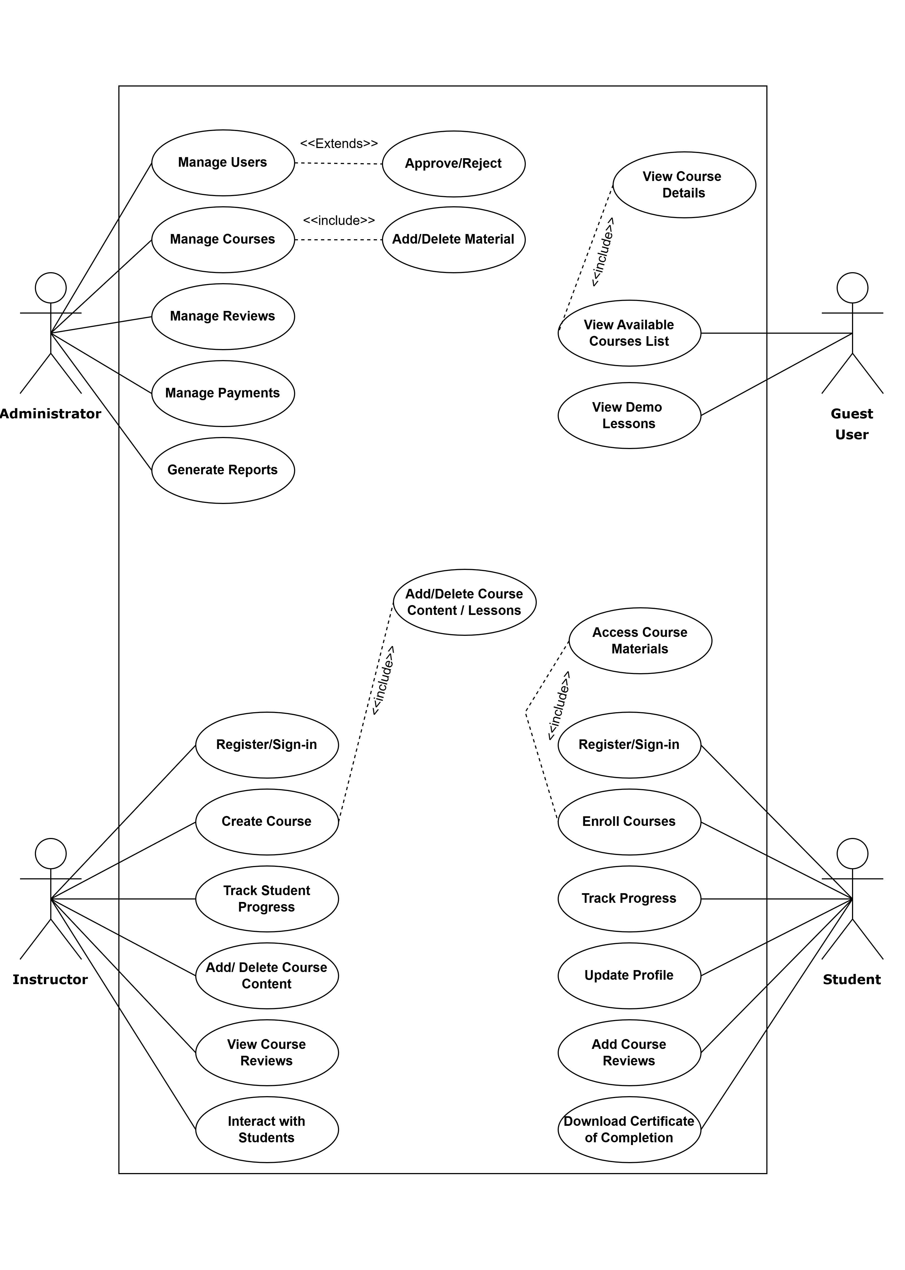
Use-Case Diagram of Complete Project

Usage Scenarios:
1. Use Case: Add/Delete Course
Use Case Title | Add/Delete Course
Use Case ID | UC-OELP001
Actors | Administrator
Actions | 1. Log in as an administrator.  2. Navigate to course management.  3. Add or delete courses from the system.
Description | This use case allows the Administrator to add new courses to the platform or remove outdated ones. And see reviews and delete them.
Alternative Paths | If the course creation fails, an error message will be displayed.
Pre-Conditions | The Administrator must be logged in with appropriate privileges.
Post-Conditions | The course will be added or deleted successfully, and changes will reflect in the course catalog.
Exceptions | Database connection failure, permission error.
Author | BC190203051

2. Use Case: Manage Users
Use Case Title | Manage Users
Use Case ID | UC-OELP002
Actors | Administrator
Actions | 1. Log in as an administrator.  2. Navigate to user management.  3. Add, delete, or modify user roles and permissions.
Description | This use case allows the Administrator to manage all users on the platform (students, instructors, etc.).
Alternative Paths | If there is an issue while adding a user (e.g., invalid details), an error message will appear.
Pre-Conditions | The Administrator must have the appropriate permissions.
Post-Conditions | User records will be updated in the database with new roles or deleted accordingly.
Author | BC190203051
Exceptions | Invalid user details, system errors during user updates.

3. Use Case: Create New Courses
Use Case Title | Create New Courses
Use Case ID | UC-OELP003
Actors | Instructor
Actions | 1. Log in as an instructor.  2. Navigate to course creation dashboard.  3. Add course title, description, and lessons.
Description | This use case allows an instructor to create a new course by adding relevant details such as course content and structure.
Alternative Paths | If media upload fails, the instructor can retry or use a different format.
Pre-Conditions | The instructor must be logged in and have the role of course creator.
Post-Conditions | The new course will be added to the course catalog for students to view or enroll.
Author | BC190203051
Exceptions | Media upload failure, missing required fields.
4. Use Case: Enroll in Courses
Use Case Title | Enroll in Courses
Use Case ID | UC-OELP004
Actors | Students
Actions | 1. Log in as a student.  2. Browse course catalog.  3. Select a course and enroll.
Description | This use case allows students to view available courses and enroll in their desired courses.
Alternative Paths | If a course is full or unavailable, an alternative course will be suggested.
Pre-Conditions | The student must have an active account on the platform.
Post-Conditions | The student is successfully enrolled in the course, and the course will be added to their learning path.
Author | BC190203051, Any Student, Guest User
Exceptions | Course enrollment failure, invalid payment method.

5. Use Case: Provide Course Feedback
Use Case Title | Provide Course Feedback
Use Case ID | UC-OELP005
Actors | Student
Actions | 1. Log in as a student.  2. Complete a course.  3. Rate and provide feedback for the course.
Description | This use case allows students to provide ratings and written feedback after completing a course.
Alternative Paths | If the feedback submission fails, the system will show an error message and ask to retry.
Pre-Conditions | The student must have completed the course to leave feedback.
Post-Conditions | The feedback is stored and visible to the instructor and other students.
Author | BC190203051, Any Student
Exceptions | Feedback submission failure, system timeouts.

6. Use Case: Track Course Progress
Use Case Title | Track Course Progress
Use Case ID | UC-OELP006
Actors | Student
Actions | 1. Log in as a student.  2. Navigate to course progress page.  3. View completion percentage, progress bar, and upcoming assignments.
Description | This use case allows students to track their progress through enrolled courses.
Alternative Paths | If progress is not tracking properly, the system will prompt for re-syncing.
Pre-Conditions | The student must be logged in and enrolled in at least one course.
Post-Conditions | The system will display accurate progress information and reminders for uncompleted assignments.
Author | BC190203051
Exceptions | Progress tracking error, incomplete assignments.

7. Use Case: Generate Reports (Administrator)
Use Case Title | Generate Reports
Use Case ID | UC-OELP007
Actors | Administrator
Actions | 1. Log in as an administrator.  2. Navigate to Dashboard section.  3. Can View user activity and course performance reports.
Description | This use case allows the administrator to get detailed reports on user activities and course performance.
Alternative Paths | If the report generation fails, the system will provide an error message and retry options.
Pre-Conditions | The administrator must have access to reporting tools and data.
Post-Conditions | The requested reports will be displayed in tables format.
Author | BC190203051
Exceptions | Report generation failure, data unavailability.

8. Use Case: Monitor Student Performance
Use Case Title | Monitor Student Performance
Use Case ID | UC-OELP008
Actors | Instructor
Actions | 1. Log in as an instructor.  2. Navigate to student performance dashboard.  3. Review student engagement and course completion data.
Description | This use case allows instructors to track the performance of their students in terms of engagement and assignments completed.
Alternative Paths | If data fails to load, the instructor can retry or contact support.
Pre-Conditions | The instructor must be logged in and have enrolled students.
Post-Conditions | The performance data will be displayed and updated for instructors.
Author | BC190203051
Exceptions | Data sync failure, incomplete student data.

9. Use Case: Browse Available Courses
Use Case Title | Browse Available Courses
Use Case ID | UC-OELP009
Actors | Guest User
Actions | 1. Visit as a guest user.  2. Navigate the course catalog.  3. View course details such as description, rating, and instructor.
Description | This use case allows a guest user to browse available courses without needing to register or log in.
Alternative Paths | If courses are unavailable, the system will display a message and suggest similar courses.
Pre-Conditions | The user must not be logged in or must be a guest.
Post-Conditions | The user will be able to explore course catalogs and details but cannot enroll without an account.
Author | BC190203051
Exceptions | Data loading issues, no courses available.

Adopted Methodology
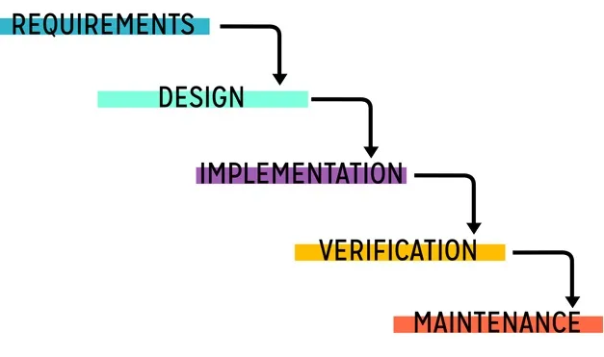
The Software Development Life Cycle (SDLC) is a structured process used to create high-quality software efficiently. It involves stages like Requirement Analysis, Design, Implementation, Testing, Deployment, and Maintenance, ensuring systematic development. The VU Process Model, based on SDLC, combines the linear approach of the Waterfall Model with the iterative refinement of the Spiral Model. It ensures step-by-step progress while allowing flexibility through feedback loops. This makes it ideal for our PHP-based e-learning platform, balancing structure and adaptability. Clear stages and risk management ensure smooth development and high-quality outcomes. That’s why I’m going to use VU Process model for this whole project.

Benefits of Using VU Process Model:
- Combines Strengths of Waterfall and Spiral Models: It follows a structured approach of the waterfall model while integrating iterative cycles from the spiral model for better risk management.
- Sequential and Easy to Understand: Each phase is specific, well-organized, and processed one at a time, ensuring clarity and focus.
- Enhanced Risk Avoidance: The iterative nature of the model allows for identifying and addressing risks early in the development process.
- Supports Adding Features Later: Additional functionalities can be incorporated in iterative cycles, ensuring flexibility without disrupting earlier phases.
- Ensures Quality and Feedback: The spiral approach provides opportunities to incorporate client feedback during iterations, improving the final product.
- This model suits projects that require a mix of structure and adaptability, like this e-learning platform.

Work Plan (Use MS Project to create Schedule/Work Plan)
